Create ‘API key’ type credentials:

Machine generated alternative text:
Google APIs 
Appointments 
Search for APIs and Services 
+ CREATE CREDENTIALS 
o. 
APIs & Services 
Google Calendar API 
Overview 
Metrics 
Quotas 
Credentials 
Credentials 
DELETE 
Credentials compatible with this API 
To view all credentials or create new credentials visit Credentials in APIs & Services 
OAuth 2.0 Client IDs 
Name 
Web client 1 
Service Accounts 
Email 
Creation date 
Mar g, 2021 
Type 
Web application 
Client ID 
922156912528-415n. 
0 
Manage service accounts 
Name 
Appointments 

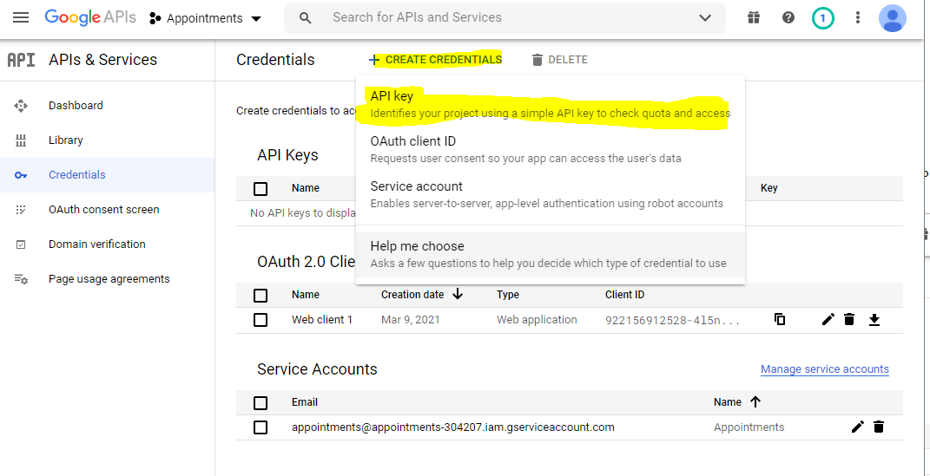

Machine generated alternative text:
RPI 
o. 
AlzaSyDOOr.. .xvGIYY7aGs 
APIs & Services 
Dashboard 
Library 
Credentials 
OAuth consent screen 
Domain verification 
Page usage agreements 
Credentials 
+ CREATE CREDENTIALS 
DELETE 
Create credentials to access your enabled APIs. Learn more 
API Keys 
Name 
A APIkey1 
Creation date 
Mar 11, 2021 
OAuth 2.0 Client IDs 
Name 
Web client 1 
Creation date 
Mar g, 2021 
Restrictions 
Type 
Web application 
Client ID 
922156912528-415n 